SAVONIUS WIND TURBINE REPORT
- Description
In this report a savonius type wind turbine analysis is studied. In analysis method, Ansys CFX solver is used. First, geometry of wind turbine is determined via Spaceclaim software. Second step was determining the meshes to the geometry. Final step was determining calculation method, iteration way for calculation. K-epsilon model is used while solving. Ansys CFX software was used for this process.
Aim of the report is to find the power of the turbine, and after determining the power, Cp(Power Coefficient) value can be calculated.

Assumptions
Wind Speed: 7 m/s
Rotational Speed of Turbine: 90 rpm
Density of Air: 1.184 kg/m³ (air at 25 ºC, 1 atm)

- Geometry
The turbine which is a savonius type has 1 meter of diameter and 1 meter height.
There can be seen the geometry of the turbine. Turbine has 2 wings which are equals to each other as dimensions.
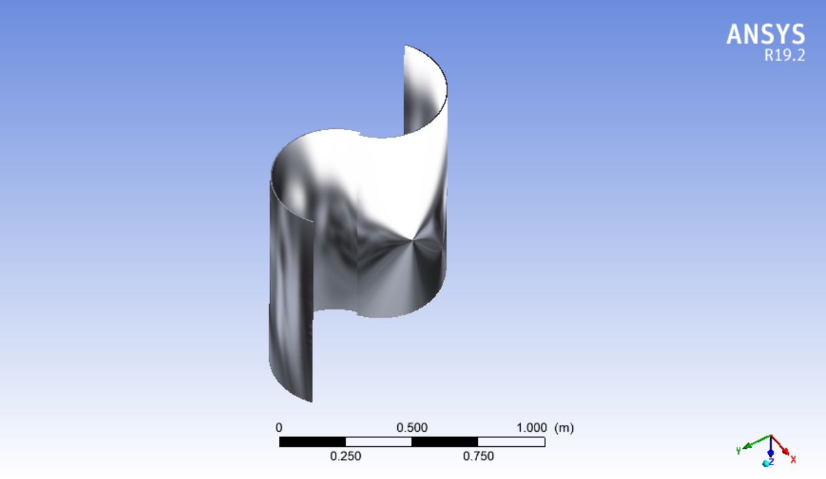
Figure 1. Geometry of The Turbine Wings

- Mesh Determination
In the model, mesh quality is considered as one of the key parameter for the result. There can be seen below the skewness of the meshes. As it can be seen from Figure 2, mesh skewness was appropriate for the analysis since max skewness value is below 0,8 value.
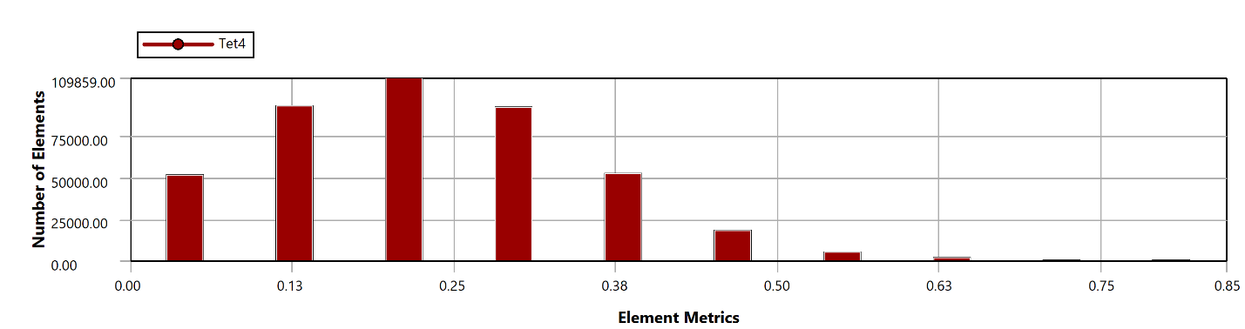
Figure 2. Mesh Skewness

- Results
According to the solving via Ansys CFX, there can be seen pressure on the turbine wings.
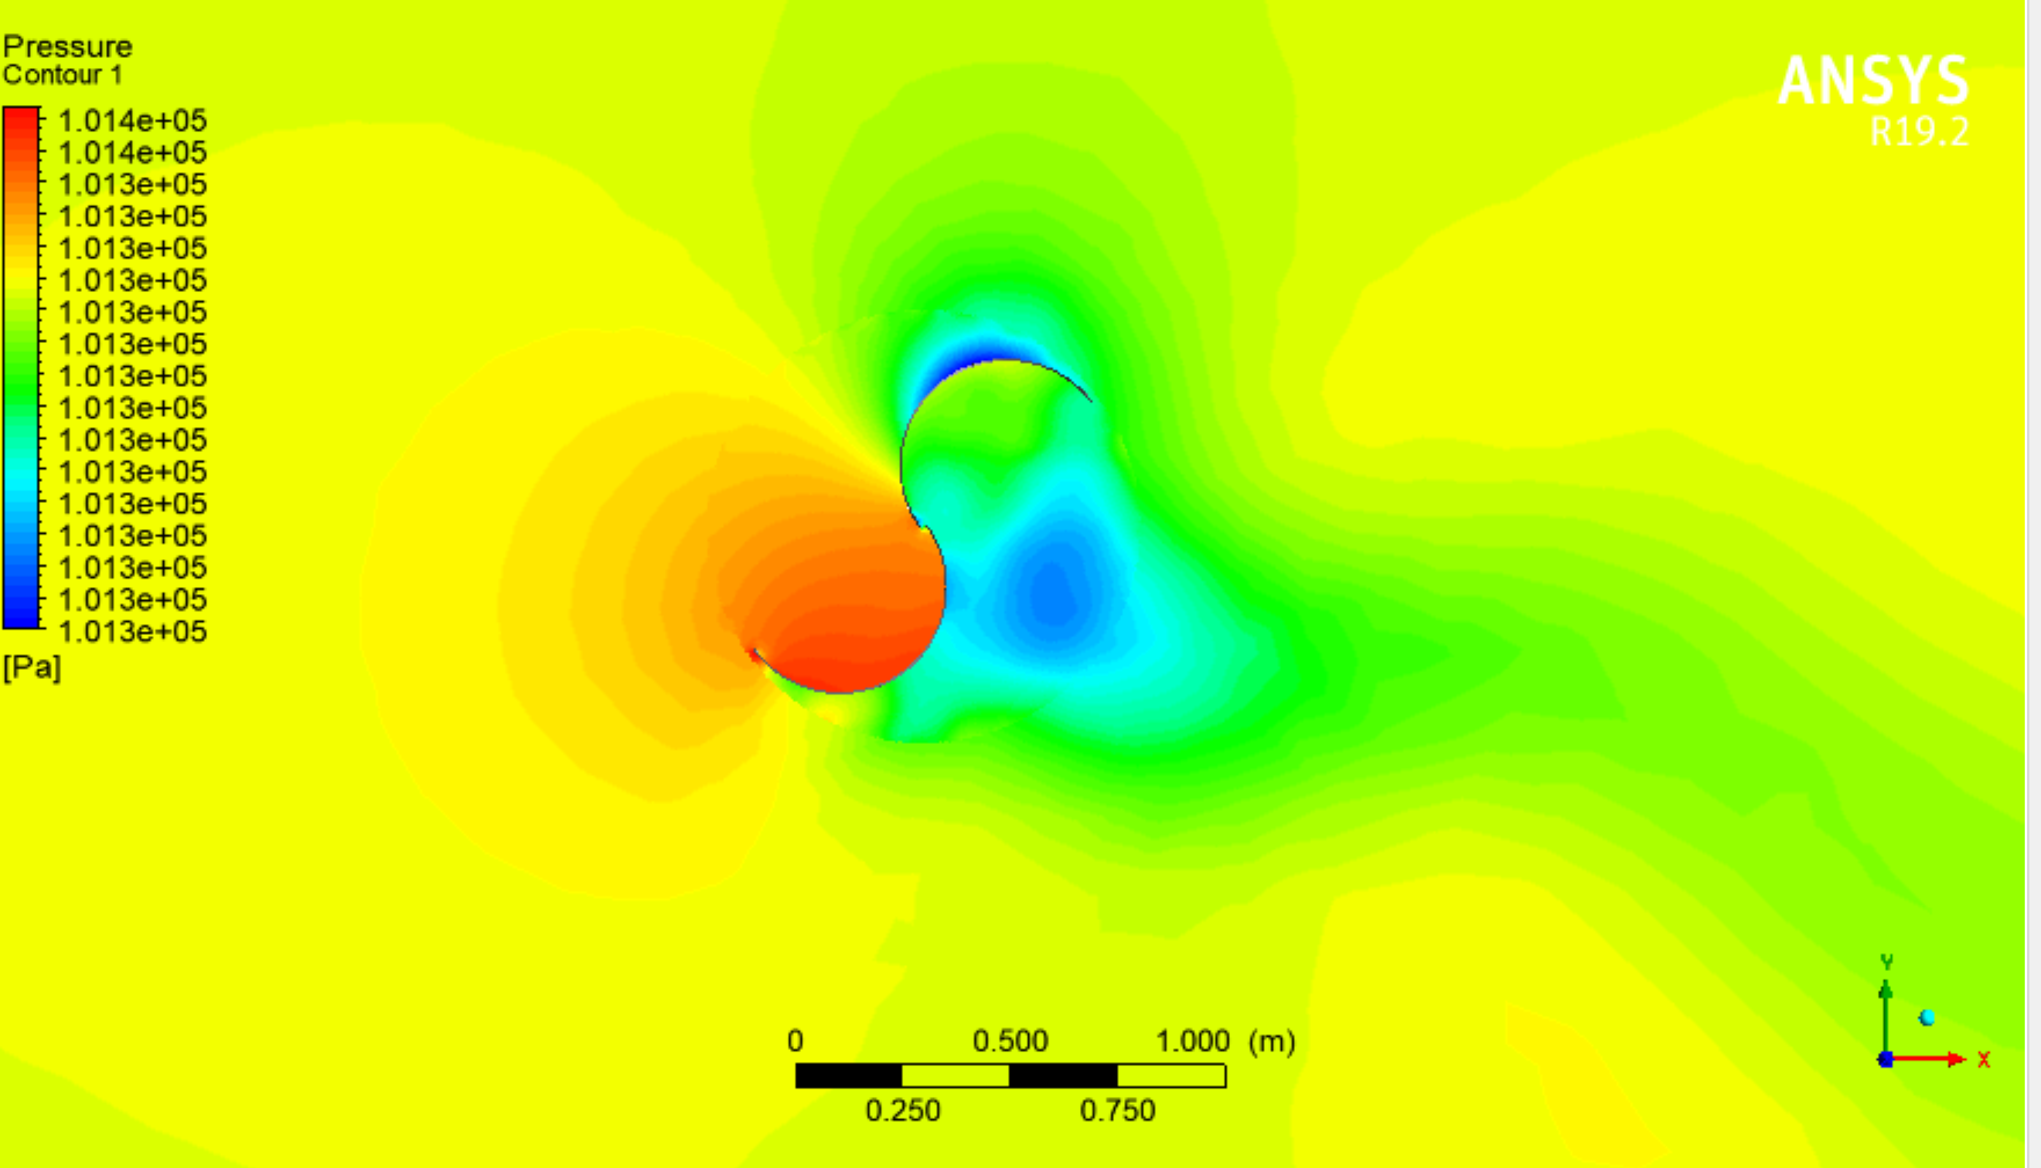
Figure 3. Pressure on the Wings

Pressure on the wings were found as appropriate for the rotation since there is differential pressure on the wings.
Power output for the wind turbine was calculated in the software. Equation was determined to and than according to the torque value, power calculation was done. According to the calculation, the turbine has approximately 60 W power generation value. While calculating power output, torque value of the wings was calculated by the simulation program. So, power was calculated with the information of the rotational speed according to the equation 1.
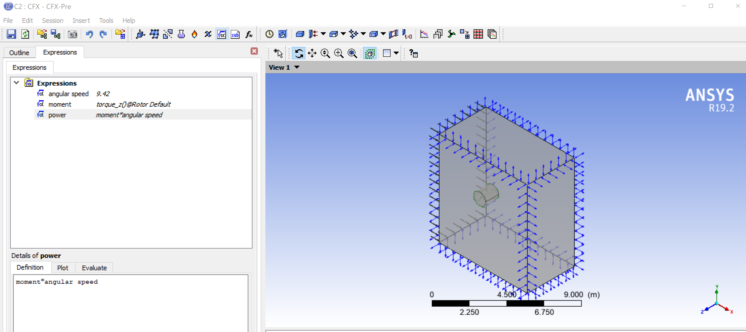
Figure 4. Power Calculation

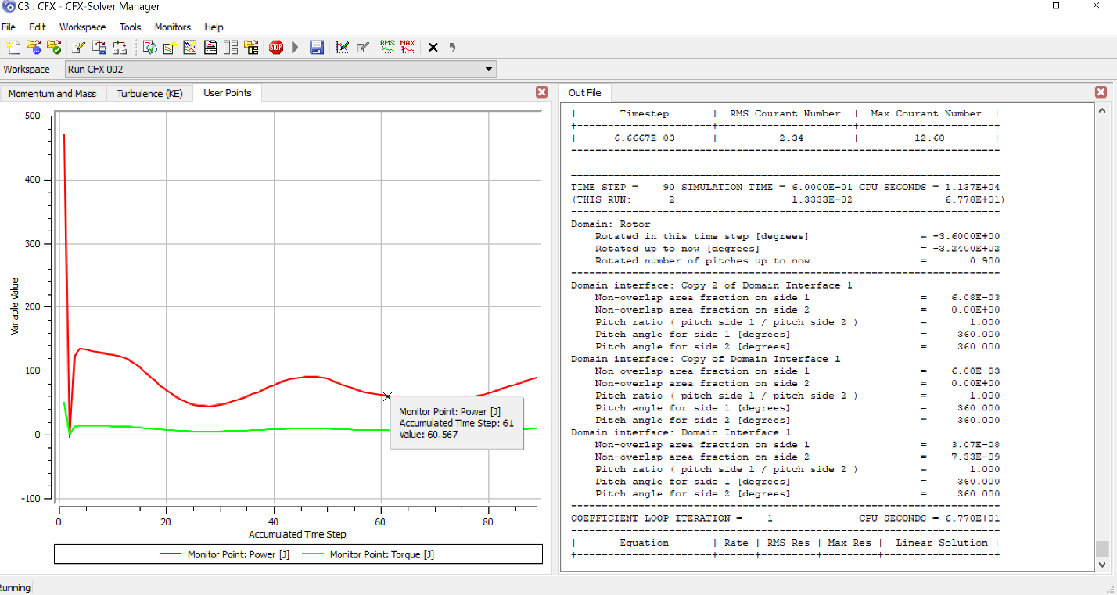
Figure 5. Power and Torque Chart
Power (Watt)= Torque(moment)*Angular Speed Equation (1)
Cp(Power coefficient) is calculated according to the power which is obtained by turbine and maximum available power from the wind. It can be seen from Equation 2.
Cp= Power/ Available Power Equation (2)
Available Power=0,5*density*Surface of the Rotor*Wind Speed³ Equation (3)
Density= 1.184 kg/m³ (air at 25 ºC, 1 atm)
Surface of The Rotor= Height*Diameter of the Rotor=1*1 m²
Wind Speed=7 m/s
Avail. Power=0.5*1.184*1*7³=203.056 W
Consequently, Cp(Power Coefficient) value is calculated:
Cp=Power/Avail. Power=60/203=0.295

Cp value is calculated as 0,295. These calculations showed similar results to studies in the literature. So, it is considered as a logical simulation for real applications.

REFERENCES
Gasch,R. (2002). Wind Power Plants Fundamentals, Design, Construction and Operation

